What is Swing in Java?
Swing is a GUI (Graphical User Interface) toolkit for Java. It is part of Java Foundation Classes (JFC) and is used to create window-based applications (like buttons, text fields, menus, tables, etc.).
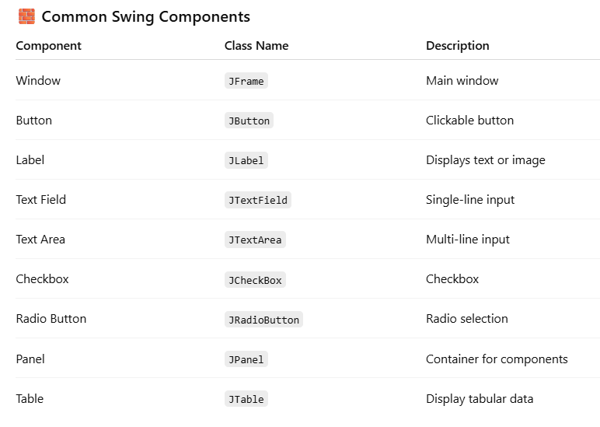

What is NetBeans GUI Builder?
The GUI Builder in NetBeans lets you visually design user interfaces using Swing components — no manual coding of layout managers or component placement is needed.

What is JDBC?
JDBC (Java Database Connectivity) is an API in Java that allows Java applications to connect and interact with relational databases like MySQL, PostgreSQL, Oracle, etc.

Why I Used MySQL Over Other Databases:
"I chose MySQL because it's open-source, widely supported, and has a strong community. It integrates easily with Java using JDBC, is lightweight for development, and is commonly used in both academic and industry projects.
It also provides good performance for read-heavy workloads, has excellent tools like phpMyAdmin and MySQL Workbench, and is easy to set up locally for development.
For my project’s requirements — which included structured data and SQL-based queries — MySQL was a reliable and familiar choice."

What is Jaspersoft?
Jaspersoft is an open-source reporting and data analytics platform. It allows developers and businesses to create interactive reports, dashboards, and data visualizations from various data sources.

